EXERCÍCIO FORM007.HTML

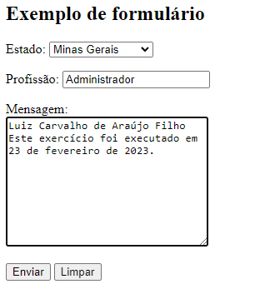

<body>

<h**2**>Exemplo de formulário</**h2**>

<**form** **action**="**cadastro.php**" **method**="**get**" **autocomplete**="**on**">

<**div**>

<**label** **for**="i**_est**"> **Estado:** </**label**>

<**select** **name**="**estado**" **id**="**i**_**est**">

<**optgroup** **label**="**Região Sudeste**">

<**option** **value**="**MG**">**Minas** **Gerais**</**option**>

<**option** **value**="**RJ**">**Rio** **de** **Janeiro**</**option**>

<**option** **value**="**SP**">**São** **Paulo**</**option**>

</**optgroup**>

<**optgroup** **label**="**Região Nordeste**">

<**option** **value**="**AL**">**Alagoas**</**option**>

<**option** **value**="**PE**">**Pernanbuco**</**option**>

<**option** **value**="**MA**">**Maranhão**</**option**>

</**optgroup**>

</**select**>

<p>

<**label** **for**="**i-profissao**">**Profissão**:</**label**>

<**input** **type**="**text**" **name**="**profissao**" **id**="**i-profissao**" **list**="**lstprof**">

<**datalist** **id**="**lstprof**">

<**option** >**Administrador**</**option**>

<**option** >**Desenvolvedor**</**option**>

<**option** >**Professor**</**option**>

<**option** >**Contador**</**option**>

</**datalist**>

</p>

<p>

<**label** **for**="**i-mens**">**Mensagem**:</**label**> <**br**>

<**textarea** **name**="**mens**" **id**="**i-mens**" **cols**="**30**" **rows**="**10**"></**textarea**>

</p>

<p>

<**input** **type**="**submit**" **value**="**Enviar**">

<**input** **type**="**reset**" **value**="**Limpar**">

</**div**>

</**form**>

</**body**>